CAPSTONE PROJECT WORK REPORT
Phase I
AI Resume Analyzer and Job Recommendation System

RASHVANDH A
(REG. NO. 2428C0504)
A report submitted in partial fulfillment of the degree of
B.Sc. Artificial Intelligence and Machine Learning

Supervisor: Dr. S. Janani M.C.A., M.Phil., Ph.D.,
Assistant Professor, Dept. of AI and ML

Department of Artificial Intelligence and Machine Learning KPR College of Arts Science and Research

(Affiliated to Bharathiar University, Coimbatore) Avinashi Road, Arasur, Coimbatore-641407

March 2025

CAPSTONE PROJECT WORK REPORT
Phase I
Hematology Disease Prediction Using Machine Learning Bonafide Work Done by

RASHVANDH A
(REG. NO. 2428C0504)

Dissertation submitted in partial fulfillment of the requirements for the award of
B.Sc. Artificial Intelligence and Machine Learning of Bharathiar University, Coimbatore-46.


Signature of the Guide Signature of the HOD

Submitted for the Viva-Voce Examination held on

Internal Examiner External Examiner

March 2025

Acknowledgment

I am writing this acknowledgment to express my deepest gratitude for the support and guidance you have provided me during the course of my capstone project.

I would like to convey my profound gratitude to Dr. P. Geetha, Principal of KPR College of Arts Science and Research, for her endless support. I would also like to extend my sincere thanks to Dr. P. Pradeepa, Dean, School of Computing Science, and our beloved Dr. R. Kumuthaveni M.C.A., M.Phil., Ph.D., Associate Professor & Head, Dept. of AI and ML, for providing moral support and motivation throughout the project.

It's my privilege to thank Dr. S. Janani M.C.A., M.Phil.,Ph.D., Assistant professor, Department of Artificial Intelligence and Machine Learning, for her valuable support and suggestions. I feel privileged to have had the opportunity to learn from her, and I am grateful for the valuable lessons and experiences that I have gained under her guidance.

Student Signature

Place: Coimbatore Date:

CONTENTS

Section No. | Section Title | Page No.
 | Acknowledgment | 2
 | Contents | 3
 | Synopsis | 4
1. | 1. Introduction  - Organization Profile  - System Specification  - Hardware Configuration  - Software Specification | 5-8
2. | 2. System Study  - Existing System  - Drawbacks  - Proposed System  - Features | 9-11
3. | 3. System Design and Development  - File Design  - Input Design  - Output Design  - Database Design  - System Development  - Description of Modules (Detailed Explanation+) | 12-18
4. | Software Testing and Implementation | 19-22
5. | Conclusion | 23-24
6. | Bibliography | 25-26
7. | Appendices  - Data Flow Diagram  - Table Structure  - Sample Coding  - Sample Input  - Sample Output | 27-32

AI Resume Analyzer and Job Recommendation System

Synopsis

In today’s highly competitive job market, organizations receive an overwhelming number
of resumes for each job opening. Manual screening of resumes is time-consuming, inefficient,
and often influenced by human bias.

The AI Resume Analyzer and Job Recommendation System is designed to automate resume evaluation using Artificial Intelligence and Natural Language Processing techniques.
The system allows users to upload resumes in PDF or text format. It extracts important information such as skills, education, experience, and projects using text processing techniques.

The extracted information is then analyzed using TF-IDF vectorization and cosine similarity algorithms to match candidate resumes with job descriptions stored in the system database.
The platform also calculates an ATS (Applicant Tracking System) score based on multiple evaluation parameters such as skill relevance, experience depth, resume structure, keyword density, and project impact.

Additionally, the system integrates an AI chatbot module powered by Large Language Models (LLMs) that provides career guidance and resume improvement suggestions.
The system is implemented using a FastAPI backend for high-performance processing and a modern web frontend built using HTML, CSS, and JavaScript.

By automating resume screening and job recommendation, the system helps recruiters identify suitable candidates efficiently and enables job seekers to improve their resumes and career prospects.

- Introduction

With the rapid growth of digital recruitment platforms and online job portals, organizations are receiving an unprecedented number of job applications. Human resource professionals face significant challenges in efficiently reviewing and selecting suitable candidates.

Traditional recruitment methods rely heavily on manual resume screening, which requires considerable time and effort. This process may also result in inconsistent evaluations due to subjective bias and human fatigue.

Artificial Intelligence and Machine Learning technologies provide innovative solutions to automate recruitment processes. By applying Natural Language Processing techniques, resumes can be analyzed to extract meaningful information and determine candidate suitability for specific job roles.

The AI Resume Analyzer and Job Recommendation System is developed to streamline the recruitment process by automatically analyzing resumes, extracting technical skills, calculating ATS scores, and recommending suitable job opportunities.

Project Objectives

The main objective of this project is to design and implement an intelligent system capable of analyzing resumes and recommending job roles.
Specific objectives include:

• Automating resume parsing and extracting candidate information
• Identifying technical skills using keyword detection techniques
• Matching resumes with job descriptions using similarity algorithms
• Generating ATS scores based on resume quality parameters
• Providing resume improvement suggestions
• Integrating AI chatbot for career guidance
• Developing an interactive web application

Significance of the Project

This project helps reduce manual effort in recruitment processes and improves hiring efficiency. It provides data-driven insights to recruiters and offers personalized feedback to candidates.

The system ensures unbiased evaluation by relying on machine learning algorithms rather than human judgment.

1.1 Organization Profile

Introduction to KPR College of Arts Science and Research (KPRCAS)
KPR College of Arts Science and Research (KPRCAS) is a premier institution in Tamil Nadu, established in 2019 under the prestigious KPR Group. Affiliated with Bharathiar University, Coimbatore, the college is dedicated to academic excellence, innovation, and industry-oriented education. Situated in Arasur, Coimbatore, KPRCAS provides a world-class learning environment with a strong emphasis on research and practical knowledge application.

Vision and Mission
Vision: To be a globally recognized institution that imparts knowledge and life skills to students, shaping them into responsible citizens who contribute to society’s growth and development.

Mission:
- To provide high-quality education that blends theoretical and practical knowledge.
- To equip students with industry-relevant skills and enhance employability.
- To promote research and development in emerging fields like Artificial Intelligence, Data Science, and Cybersecurity.
- To instill ethical values, leadership qualities, and lifelong learning habits in students.

1.2 System Specification
The AI Resume Analyzer system is designed to perform intelligent resume processing using machine learning and text mining techniques.
The system performs the following operations:
• Resume upload and text extraction
• Skill detection and classification
• Job similarity calculation
• ATS score generation
• Resume improvement suggestion generation
• AI chatbot interaction
1.3 Hardware Configuration

Component | Specification
Processor | Intel Core i5 / equivalent
RAM | 8 GB or above
Storage | 256 GB SSD
Internet | Required for API access
System Type | 64-bit System
1.4 Software Specification

Component | Details
Operating System | Windows 11
Development Environment | VS Code
Programming Language | Python
Backend Framework | FastAPI
Frontend | HTML, CSS, JavaScript
Machine Learning | Scikit-learn
NLP | TF-IDF, Cosine Similarity
APIs | Groq API / LLM APIs

- System Study
The recruitment process is an essential activity for organizations aiming to hire skilled candidates. However, traditional resume screening methods are inefficient when dealing with large application volumes.
Artificial Intelligence provides solutions to automate candidate evaluation by analysing resume content and comparing it with job requirements.

Existing System
The traditional recruitment process involves manual resume screening performed by HR professionals. Recruiters read each resume individually and compare candidate qualifications with job requirements.
Some organizations use basic Applicant Tracking Systems (ATS) that filter resumes using simple keyword matching techniques. However, these systems often fail to understand semantic meaning and contextual relevance.

Drawbacks of the Existing System
The current recruitment systems have several limitations:
- Manual Screening: Requires significant human effort and time.
- Human Bias: Recruiters may unintentionally Favor certain candidates.
- Keyword Dependency: Basic ATS systems rely only on exact keyword matches.
- Lack of Feedback: Candidates do not receive suggestions to improve their resumes.
- Limited Intelligence: Existing systems cannot understand the context of candidate skills.

Proposed System
The proposed system introduces an AI-powered resume analysis platform that automates candidate evaluation using machine learning and NLP techniques.

The system performs the following functions:

• Automatically extracts information from resumes
• Identifies candidate skills and experience
• Matches resumes with job descriptions using similarity algorithms
• Generates ATS scores
• Provides resume improvement suggestions
• Offers AI-based career guidance via chatbot

Features

The AI Resume Analyzer provides several advanced features:
- Resume parsing and information extraction
- Skill detection using a technical skill database
- Job recommendation based on resume analysis
- ATS score generation and resume quality evaluation
- Resume improvement suggestions
- AI chatbot for career advice
- Interactive web interface

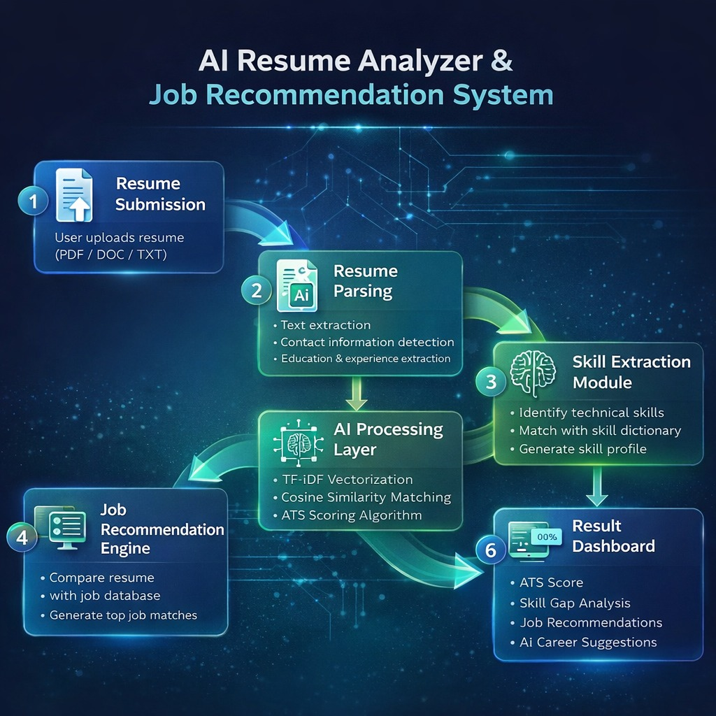
3. System Design and Development
The system design phase focuses on defining the architecture, data flow, input-output structure, database schema, and module functionality of the AI Resume Analyzer and Job Recommendation System.
The development process follows a modular architecture to ensure scalability, maintainability, and performance optimization.
3.1 File Design
The project is divided into multiple files to maintain modularity and improve code reusability.
- Backend Server File (backend_main.py)
This file acts as the core processing engine of the system.
Functions performed:
• Handles resume upload requests
• Extracts text from resume files
• Performs skill extraction
• Calculates ATS score
• Computes job similarity using TF-IDF
• Communicates with AI chatbot API
• Sends processed results to frontend

2. Resume Parsing Module (resume_parser.py)
Responsible for extracting structured information from raw resume text.
Tasks performed:
• Email detection using Regular Expressions
• Phone number extraction
• Experience keyword detection
• Education identification
• Section classification

3. Skill Dictionary File (skills_db.json)
Contains categorized technical skills.
Example categories:
• Programming Languages
• Web Development
• Cloud Technologies
• Data Science Tools
• Databases

4. Job Database File (job_database.json)
Stores job descriptions.
Each record contains:
• Job ID
• Job Title
• Job Category
• Required Skills
• Job Description

5. Frontend File (index.html)
Provides interactive user interface.
Features include:
• Resume upload
• Skill visualization
• ATS score dashboard
• Job recommendation cards
• Chat interface

3.2 Input Design
Input design ensures that the system accepts user data efficiently and validates it before processing.
Input Type
The system accepts:
• PDF Resume Files
• Text Resume Files

Input Process
- User uploads resume through drag-and-drop interface
- File is converted into raw text
- Text is cleaned using preprocessing techniques
- Important keywords and sections are extracted

Validation
• File type validation
• File size validation
• Empty content detection
• Unsupported format rejection

3.3 Output Design
The system generates multiple outputs for better user understanding.
1. ATS Score Output
Displays overall resume quality score (0–100)
Breakdown includes:
• Skill Match Score
• Experience Score
• Resume Structure Score
• Keyword Density Score

2. Job Recommendation Output
Displays:
• Top 5 matching job roles
• Match percentage
• Missing skills

3. Improvement Suggestions Output
Examples:
• Add measurable achievements
• Include more technical projects
• Improve skill keyword coverage

4. Chatbot Output
Provides real-time career advice.

3.4 Database Design
The system uses structured JSON-based in-memory databases.
Job Table Structure
Field | Description
job_id | Unique Identifier
job_title | Name of Role
category | Field of Job
skills | Required Skills
description | Job Overview

Skill Table Structure
Field | Description
skill_name | Technology Name
category | Skill Type
importance_weight | Matching Priority

3.5 System Development
The system is developed using an agile methodology.
Development Steps
- Requirement analysis
- Resume dataset preparation
- Skill extraction module implementation
- TF-IDF similarity engine development
- Backend API creation
- Frontend UI development
- Integration testing
- Deployment

Technology Stack
Backend → FastAPI
Frontend → HTML CSS JavaScript
Machine Learning → Scikit-learn
AI Integration → Groq API
Text Processing → TF-IDF

3.6 Description of Modules

1. Resume Extraction Module
This module is responsible for converting uploaded resume files into analysable text format.
Functions:
• Uses PDF parsing libraries
• Removes special characters
• Normalizes text
• Splits text into tokens
Benefits:
• Ensures structured data processing
• Improves keyword detection accuracy

2. Skill Extraction Module
Detects technical skills from resume content.
Process:
• Matches words with skill dictionary
• Categorizes skills
• Counts frequency
Advantages:
• Helps identify candidate specialization
• Improves job recommendation accuracy

3. ATS Scoring Module
Evaluates resume quality.
Scoring Parameters:
• Skill coverage
• Experience keywords
• Project presence
• Action verbs
• Impact metrics
This module generates a numerical score indicating resume strength.

4. Job Matching Module
Matches resume with job descriptions.
Algorithm Used:
TF-IDF Vectorization + Cosine Similarity
Working:
• Converts resume and job text into vectors
• Calculates similarity score
• Sorts job roles
Benefits:
• Semantic matching
• Avoids strict keyword dependency

5. AI Chatbot Module
Provides career suggestions.
Functions:
• Resume improvement tips
• Skill learning roadmap
• Interview preparation guidance

6. Visualization Module
Displays charts such as:
• Skill distribution
• Keyword density
• Match comparison

7. API Communication Module
Handles backend communication.
Functions:
• Sends resume data
• Receives processed results
• Displays responses
4. Software Testing And Implementation
Testing plays a crucial role in ensuring the reliability, performance, and accuracy of the AI Resume Analyzer system.
The system is tested at multiple stages to verify correct functioning of individual modules as well as overall integration.

4.1 Testing Strategies
1. Unit Testing
Unit testing focuses on testing individual components of the system independently.
Examples:
• Resume text extraction function testing
• Skill detection function validation
• ATS scoring calculation verification
• Similarity score computation testing
Benefits:
• Detects logical errors early
• Improves code reliability

2. Integration Testing
This testing ensures that all modules work together seamlessly.
Process:
• Resume upload → Backend processing → Result display
• API request → Data analysis → Frontend visualization
This confirms proper communication between:
• Frontend interface
• FastAPI backend
• Machine learning modules

3. Functional Testing
Functional testing verifies that system requirements are satisfied.
Test Cases Include:
• Upload valid resume → Correct ATS score generation
• Upload unsupported file → Error message display
• Missing skills → Improvement suggestion generation

4. Performance Testing
Evaluates system speed and efficiency.
Parameters measured:
• Resume processing time
• Similarity calculation time
• Chatbot response latency
• Concurrent user handling capability

5. Usability Testing
Ensures user-friendly experience.
Methods:
• Observing user interactions
• Collecting feedback
• UI improvement iterations
Focus areas:
• Simplicity
• Clarity
• Responsiveness

6. Security Testing
Protects sensitive resume data.
Measures include:
• Input validation
• File upload restrictions
• API authentication
• Secure data transmission

7. Regression Testing
Performed after system updates.
Purpose:
• Ensure new features do not break existing functionality
• Maintain system stability

4.2 Implementation Process

Environment Setup
Steps:
• Install Python environment
• Install FastAPI and ML libraries
• Configure API keys
• Setup frontend environment

Backend Implementation
• Create resume processing API endpoints
• Implement TF-IDF matching engine
• Integrate ATS scoring module
• Add chatbot communication logic

Frontend Implementation
• Design resume upload dashboard
• Display ATS score visually
• Show job recommendation cards
• Implement chat interface

Deployment
System can be deployed using:
• Local Server (Development Testing)
• Cloud Platforms such as AWS
• Container deployment using Docker

Continuous Monitoring
Includes:
• Performance logs
• Error tracking
• User analytics

5. Conclusion
The AI Resume Analyzer and Job Recommendation System successfully demonstrates how Artificial Intelligence can enhance modern recruitment processes.
By automating resume analysis, the system reduces the time and effort required for manual screening while improving the accuracy of candidate shortlisting.
The integration of Natural Language Processing techniques enables semantic understanding of resume content, allowing the system to match candidates with job roles more effectively than traditional keyword-based filtering systems.
The ATS scoring mechanism provides valuable feedback to candidates, helping them improve their resumes and increase their chances of selection.
Furthermore, the inclusion of an AI-powered chatbot enhances user experience by offering career guidance and skill improvement recommendations.
Overall, the system provides a scalable, efficient, and intelligent solution for both recruiters and job seekers.

Future Enhancements
• Integration of deep learning models for improved semantic understanding
• Expansion of job database
• Mobile application development
• Real-time resume ranking system
• Multi-language resume support
• Cloud-based large-scale deployment

6. Bibliography

1. Salton, G., & Buckley, C. (1988). Term-weighting approaches in automatic text retrieval. Information Processing & Management, 24(5), 513-523.
o Introduces TF-IDF weighting technique used for resume-job similarity matching.

2. Manning, C. D., Raghavan, P., & Schütze, H. (2008). Introduction to Information Retrieval. Cambridge University Press.
o Covers text processing, vector space models, and similarity measures used in resume analysis.

3. Jurafsky, D., & Martin, J. H. (2021). Speech and Language Processing. Pearson.
o Provides detailed concepts of Natural Language Processing including information extraction and semantic analysis.

4. Pedregosa, F., Varoquaux, G., Gramfort, A., Michel, V., Thirion, B., Grisel, O., & Duchesnay, É. (2011). Scikit-learn: Machine Learning in Python. Journal of Machine Learning Research, 12, 2825-2830.
o Discusses Scikit-learn library used for implementing TF-IDF vectorization and similarity computation.

5. Aggarwal, C. C. (2018). Machine Learning for Text. Springer.
o Explains text classification and feature extraction methods useful in resume categorization.

6. Bekkerman, R., & Gavish, M. (2011). High-precision phrase-based document classification on a modern scale. Proceedings of the ACM SIGKDD Conference.
o Relevant for skill-based resume classification systems.

7. Lops, P., de Gemmis, M., & Semeraro, G. (2011). Content-based recommender systems: State of the art and trends. Recommender Systems Handbook. Springer.
o Provides recommendation algorithms applicable in job suggestion modules.

8. Ricci, F., Rokach, L., & Shapira, B. (2015). Recommender Systems Handbook. Springer.
o Covers collaborative and content-based filtering techniques used in job recommendation engines.

9. Malinowski, J., Keim, T., Wendt, O., & Weitzel, T. (2006). Matching people and jobs: A bilateral recommendation approach. Proceedings of the Hawaii International Conference on System Sciences.
o Discusses automated job matching systems relevant to resume analyzers.

10. Xu, Y., & Wang, X. (2017). Resume information extraction with deep learning techniques. IEEE Conference on Information Processing.
o Demonstrates extraction of structured data from resumes using AI models.

11. Huang, J., Ertekin, S., & Giles, C. L. (2006). Efficient name disambiguation for large-scale databases. IEEE Transactions.
o Useful for candidate identity detection and information extraction challenges.

12. Devlin, J., Chang, M. W., Lee, K., & Toutanova, K. (2019). BERT: Pre-training of deep bidirectional transformers for language understanding. NAACL Conference.
o Introduces transformer models that enhance semantic resume understanding.

13. Vaswani, A., Shazeer, N., Parmar, N., et al. (2017). Attention is all you need. NeurIPS Conference.
o Presents transformer architecture used in modern NLP-based recruitment AI systems.

14. Zhang, S., Yao, L., Sun, A., & Tay, Y. (2019). Deep learning based recommender system: A survey. ACM Computing Surveys.
o Explains neural recommendation techniques applicable in intelligent job matching.

15. Russell, S., & Norvig, P. (2020). Artificial Intelligence: A Modern Approach. Pearson.
o Covers foundational AI techniques relevant for intelligent recruitment solutions.

16. FastAPI Documentation. (2024). High-performance Python API framework.
o Used for developing backend processing APIs in the project.

17. Mozilla PDF.js Documentation. (2024). JavaScript PDF rendering library.
o Used in frontend resume preview functionality.

7. Appendices

A. Data Flow Diagram

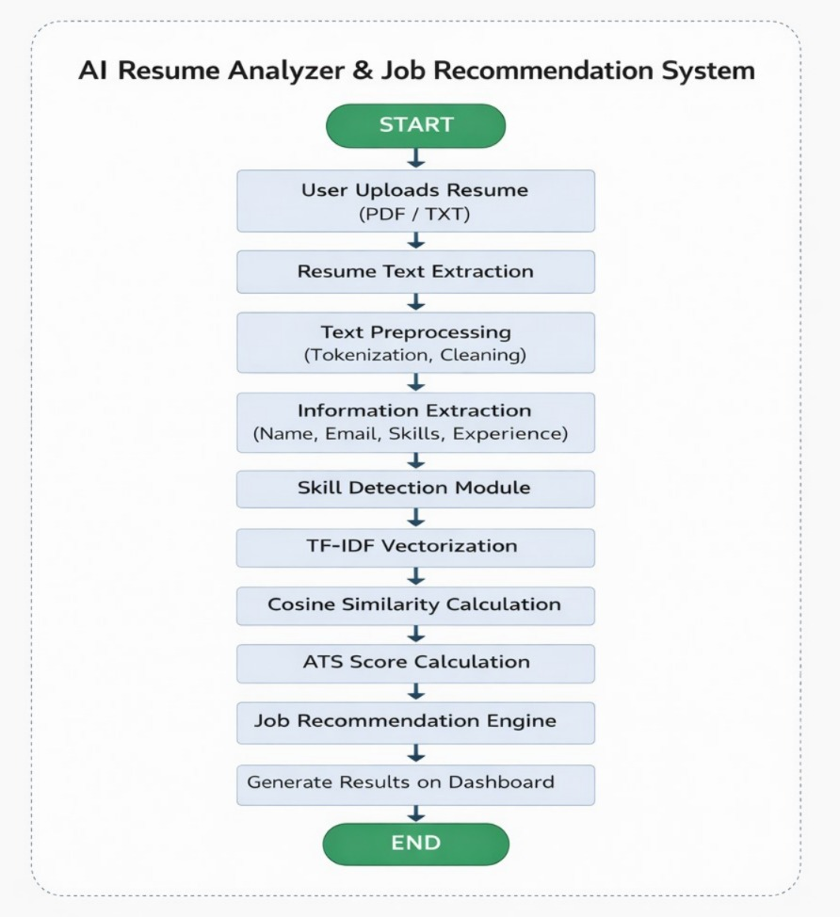

B. Sample Coding

Sample Coding: Main Analysis Endpoint
```python
@app.post("/analyze")
async def analyze_resume(request: TextAnalysisRequest):
text = request.resume_text

# Information Extraction
skills = extract_skills_from_text(text)
exp_level = estimate_experience_level(text)
category = predict_category(skills)

# Scoring and Job Matching
scores = score_resume(text, skills, detect_sections(text))
job_matches = []
for job in JOB_DATABASE:
similarity = tfidf_cosine_similarity(text, job["description"])
job_matches.append({
"title": job["title"],
"match_percentage": round(similarity * 100 * 1.8, 1)
})

return {"candidate": {"experience": exp_level}, "scores": scores, "top_matches": job_matches}
```

#### C. Sample Coding: Scoring Algorithm
```python
def score_resume(text, skills, sections):
scores = {}
# 1. Skill Coverage (30)
scores["skill_coverage"] = min(30, len(skills) * 2)
# 2. Experience Depth (20)
exp_score = 15 if any(w in text.lower() for w in ["senior", "lead"]) else 8
scores["experience_depth"] = exp_score
# 3. Impact Metrics (15)
nums = re.findall(r'\d+%|\d+x|\$\d+', text)
scores["impact_metrics"] = min(15, len(nums) * 3)
# 4. ATS Compatibility (10)
ats = 0
if sections["education"]: ats += 5
if sections["experience"]: ats += 5
scores["ats_compatibility"] = ats

scores["total"] = sum(scores.values())
return scores

C. Sample Input

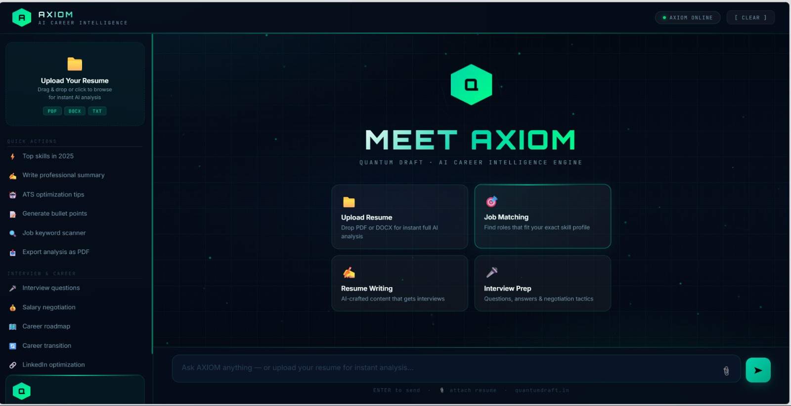

D. Sample Output

